**Sri Lanka Institute of Information Technology**

IT1040 – Fundamentals of Computing

Year 1, Semester 1 – 2024

Aqua Guard – Smart Water Tank Monitoring System

Proposal Document

Group 09.01 - PG 01

|  |  |
| --- | --- |
| IT Number | Name |
| IT24102870 | Jayasundara M. H. L. J. |
| IT24102019 | Balasooriya N. N. |
| IT24102178 | Peiris W. U. M. |
| IT24102126 | Silva K. N. T. |
| IT24100400 | Sandeepa M. S. |
| IT24100162 | Suriyaarachchi R. H. |

Table of contents

01. Project Background 1

02. Problem and Motivation 1

03. Aim and Objectives 3

04. System Diagram 4

05. Methodology 4

06. Evaluation Method 6

07. References 7

List of figures

Figure 1 : Level of water stress: freshwater withdrawal as a proportion of total renewable freshwater resources, 2019 (percentage) 2

Figure 2 : System Diagram 4

# Project Background

Water scarcity is an escalating global challenge, affecting millions of people and putting immense pressure on natural resources. Efficient water management is crucial to ensuring sustainability and meeting the growing demand for this vital resource. Traditional methods of monitoring water levels in tanks often rely on manual inspection, which can be inefficient, inaccurate, and time-consuming. This leads to frequent issues such as water wastage, overflow, and insufficient supply management in many residential, commercial, and industrial settings.

The advancement of IoT (Internet of Things) technologies offers a promising solution to these challenges. Integrating smart sensors and automation into water management systems optimizes water usage and reduces wastage. This project aims to develop a water tank monitoring system that leverages modern technology to provide accurate, real-time data on water levels and consumption patterns, thereby enhancing water management practices and contributing to environmental sustainability efforts. With the increasing emphasis on sustainable development, implementing such a system holds significant potential to make water management more efficient and reliable, addressing both local and global water challenges.

# Problem and Motivation

Despite the critical importance of effective water management, many residential and commercial facilities continue to rely on outdated and inefficient methods for monitoring water tank levels, leading to significant water wastage and mismanagement. Traditional manual inspections are prone to human error and often fail to provide timely information about water levels, leaks, or overflow conditions. This lack of precise and real-time data can result in excessive water usage, insufficient supply for daily needs, and increased operational costs. In regions facing water scarcity, these inefficiencies further exacerbate the problem, highlighting the urgent need for a more reliable and automated solution. Furthermore, the inability to remotely access water tank data prevents users from making informed decisions regarding water usage and conservation.

The motivation for developing a water tank monitoring system stems from the pressing need for efficient water management in a world facing increasing water scarcity and sustainability challenges. Water is a vital resource for life, economic development, and environmental stability. However, inefficient management and wastage have become significant issues, particularly in urban areas and regions experiencing droughts or limited water supply. This project is driven by the desire to harness technology to address these challenges and contribute to a sustainable future.

* Global Water Scarcity: According to the United Nations, over two billion people live in countries experiencing high water shortages. This alarming statistic underscores the urgent need to conserve and manage water resources more effectively. Developing a water tank monitoring system can play a crucial role in reducing unnecessary water loss and ensuring the equitable distribution of available resources.
* Technological Advancements: Recent advancements in IoT (Internet of Things), sensor technology, and data analytics provide an opportunity to revolutionize traditional water management practices. Leveraging these technologies, the project aims to create an intelligent system that offers real-time insights into water usage, thereby enhancing decision-making and enabling proactive management.
* Economic Incentives: Water-related issues such as leaks, overflows, and inefficient usage can lead to substantial financial losses for households and businesses. By developing a system that detects leaks and monitors consumption patterns, this project can contribute to significant cost savings, making water management more economically viable.
* Environmental Concerns: As global populations grow and urbanize, the strain on natural water resources intensifies, leading to negative environmental impacts such as habitat destruction and water pollution. By promoting efficient water usage and reducing waste, this project aligns with broader environmental goals to protect ecosystems and ensure the sustainability of natural resources.

Figure 1 : Level of water stress: freshwater withdrawal as a proportion of total renewable freshwater resources, 2019 (percentage)

# Aim and Objectives

The “Aqua Guard” project aims to develop an innovative water tank monitoring system that leverages IoT technology to provide real-time data on water levels and consumption patterns, thereby enhancing water management efficiency, reducing wastage, and promoting sustainable resource usage.

By integrating modern technologies, such as IoT sensors and real-time data analytics, this project seeks to provide accurate and timely information on water levels, enabling users to make informed decisions. The following objectives outline the key goals and milestones of the project, ensuring a structured approach to design, development, and implementation.

1. Identify user needs - Conduct interviews and surveys with potential users to understand their requirements and expectations for the water tank monitoring system. This will help define key features and functionalities.
2. Analyze existing solutions - Research existing water monitoring systems and IoT technologies to identify gaps and opportunities for innovation. This includes studying competitor products and understanding industry standards.
3. Define system requirements - Develop a comprehensive list of system requirements, including technical specifications, desired features, and user interface design.
4. System architecture design - Create an architecture diagram illustrating how different components of the system will interact, including sensors, microcontrollers, data processing units, and user interfaces.
5. Select hardware components - Choose appropriate sensors, microcontrollers (e.g., Arduino uno), and communication modules (e.g., Wi-Fi) based on the system requirements and budget.
6. Design software interfaces - Plan the software architecture, including data processing algorithms, user interface design, and communication protocols between hardware and software components.
7. Hardware assembly - Assemble the hardware components, including sensor placement in the water tank and connections to the microcontroller.
8. Software development - Develop the software components, including firmware for sensors, data processing algorithms, and the user interface application.
9. Integration and testing - Integrate hardware and software components to form a cohesive system and conduct initial testing to ensure they work together as expected.
10. System deployment - Deploy the water tank monitoring system in a real-world setting, ensuring that all components are correctly installed and configured.

# System Diagram

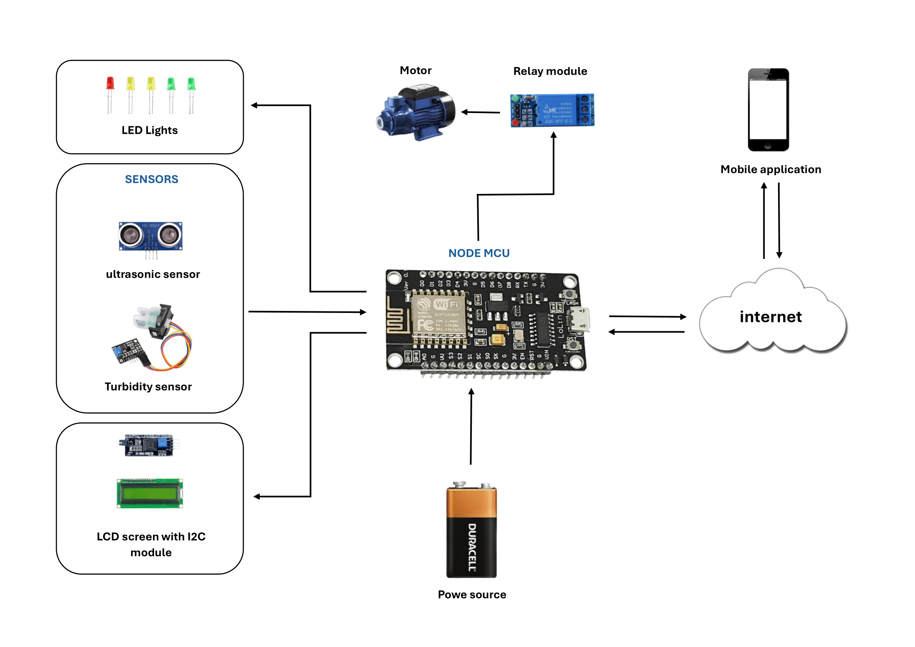

Figure 2 : System Diagram

# Methodology

A wide range of methods, tools, and technologies will be utilized for the “Aqua Guard” – the smart water tank monitoring system to ensure efficient development, testing, and deployment. This comprehensive approach will cover aspects from hardware selection to software development, user interface design, testing, and continuous integration.

1. Requirement Analysis and Planning

* Objective: To gather detailed requirements and establish a clear plan for the project.
* Methods:
  + Stakeholder Interviews: Conduct interviews with potential users, stakeholders, and domain experts to understand their needs and expectations.
  + Use Case Analysis: Define use cases and scenarios to capture functional requirements and user interactions.
  + Requirement Documentation: Create detailed requirement specifications and project scope documents to guide the development process.
* Tools:
  + Google Forms: Get feedback from stakeholders
  + Microsoft Word & Google Docs: This is used to document requirements and meeting notes.

1. System Design

* Objective: To design the system architecture and user interface, ensuring alignment with requirements.
* Methods:
  + System Architecture Design: Develop high-level architecture diagrams outlining hardware components, software modules, and data flow.
  + Wireframing and Prototyping: Create wireframes and prototypes for the user interface to visualize and refine design ideas.
  + Hardware Design: Select sensors, microcontrollers, and other components suitable for measuring water levels and transmitting data.
* Tools:
  + Figma: For designing user interfaces and creating interactive prototypes.
  + Draw.io: For drawing architecture diagrams and flowcharts.

1. Development

* Objective: To build the system according to design specifications, integrating hardware and software components.
* Methods:
  + Backend Development: Develop server-side logic to process and store sensor data.
  + Frontend Development: Create a web application for monitoring water levels, configuring alerts, and visualizing data.
* Tools:
  + Arduino IDE: For programming microcontrollers such as Arduino.
  + Visual Studio Code: As the primary IDE for development.
  + Git/GitHub: For version control, collaboration, and code repository management.

1. Testing and Quality Assurance

* Objective: To ensure the system is reliable, accurate, and user-friendly by identifying and resolving defects.
* Methods:
  + Unit Testing: Perform automated unit tests on software components to verify individual functions and modules.
  + Integration Testing: Test the integration of software components with hardware to ensure smooth operation.

1. Deployment and Integration

* Objective: To deploy the system in the target environment and ensure it integrates seamlessly with existing infrastructure.
* Methods:
  + Data Migration and Backup: Set up databases and ensure proper data migration and backup strategies.
  + Integration with Existing Systems: Ensure compatibility and integration with any existing water management systems or applications.

# Evaluation Method

The evaluation of the “Aqua Guard” – the smart water tank monitoring system will be conducted through a structured approach that focuses on ensuring the system meets its intended objectives and provides value to its users. This evaluation will be divided into specific phases, each targeting different aspects of the system to provide a comprehensive assessment.

1. Functional Evaluation - To verify that the system operates as expected and fulfills all defined functional requirements.
   1. Test Cases: Conduct a series of test cases to validate each feature, including water level measurement, real-time data transmission, alert notifications, and user interface interactions.
   2. Accuracy Checks: Compare the system's sensor readings with manual measurements to ensure they are accurate within a specified tolerance level.
   3. Integration Testing: Ensure seamless interaction between hardware components (e.g., sensors, microcontrollers) and software applications.
2. Performance Evaluation - To assess the system's efficiency, reliability, and scalability under various conditions.
   1. Response Time Analysis: Measure the time taken for the system to detect water level changes and send alerts.
   2. Load Testing: Evaluate the system's ability to handle multiple sensors and data streams simultaneously.
   3. Energy Consumption Monitoring: Analyze power usage to ensure the system is energy-efficient and sustainable.
3. User Experience and Satisfaction Evaluation - To determine the usability and user satisfaction with the system’s interface and overall functionality.
   1. Usability Testing: Conduct usability tests with end-users to assess the ease of navigation, intuitiveness, and aesthetic appeal of the user interface.
   2. User Surveys and Feedback: Distribute surveys and collect feedback from users regarding their satisfaction with the system, focusing on ease of use, reliability, and perceived value.
   3. User Interaction Analysis: Monitor user interactions to identify any usability issues or areas for improvement.
4. Impact Evaluation - To measure the system’s effectiveness in improving water management practices and achieving sustainability goals.
   1. Water Usage Analysis: Compare historical water usage data with post-implementation data to evaluate reductions in water wastage.
   2. Cost Savings Calculation: Analyze financial benefits achieved through optimized water usage, such as reduced water bills.
   3. Environmental Impact Assessment: Evaluate contributions to sustainability, such as resource conservation and reduced environmental footprint.
5. Continuous Monitoring and Improvement - To ensure the system remains effective and adaptable to changing needs and conditions.
   1. Real-Time Monitoring: Implement continuous monitoring of system performance to detect and address issues proactively.
   2. Feedback Loops: Establish ongoing feedback channels with users to gather insights and identify areas for enhancement.
   3. Iterative Updates: Apply iterative improvements based on evaluation results, user feedback, and technological advancements.

# References

[1] United Nations, “The Sustainable Development Goals Report 2022,” unstats.un.org, Jul. 07, 2022. <https://unstats.un.org/sdgs/report/2022/> (accessed Aug. 04, 2024).

[2] R. Singh et al., “Water Quality Monitoring and Management of Building Water Tank Using Industrial Internet of Things,” Sustainability, vol. 13, no. 15, p. 8452, Jul. 2021, doi: <https://doi.org/10.3390/su13158452> .

[3] L. A. Gama-Moreno, A. Corralejo, A. Ramirez-Molina, J. A. Torres-Rangel, C. Martinez-Hernandez, and M. A. Juarez, “A Design of a Water Tanks Monitoring System Based on Mobile Devices,” IEEE Xplore, Nov. 01, 2016. <https://ieeexplore.ieee.org/document/7796044> (accessed Aug. 06, 2024).

[4]S. Pasika and S. T. Gandla, “Smart water quality monitoring system with cost-effective using IoT,” Heliyon, vol. 6, no. 7, p. e04096, Jul. 2020, doi: <https://doi.org/10.1016/j.heliyon.2020.e04096> .

[5] N. Rapelli, A. Myakal, V. Kota, and P. R. Rajarapollu, “IOT Based Smart Water Management, Monitoring and Distribution System for an Apartment,” IEEE Xplore, May 01, 2019. <https://ieeexplore.ieee.org/document/9065369> (accessed Aug. 07, 2024).

[6] Sujatha Karimisetty, Prasanna Kumar Lakineni, M. Lakshmi Kamalanjali, and Pritee Parwekar, “Automated Water Flow Control System in Overhead Tanks Using Internet of Things and Mobile Application,” Lecture notes in networks and systems, pp. 805–810, Jan. 2021, doi: <https://doi.org/10.1007/978-981-33-4501-0_74> .